Project Development Phase
Performance Test
Date | 11 September 2026
Project Name | Laptop Request Management System
Maximum Marks | 10 Marks
System Performance Testing:
Project team shall fill the following information in the system performance testing template.
S.No. | Parameter | Screenshot / Values
1. | Request Data | ServiceNow laptop request records contain requester, laptop requirement, request status, approval status, and fulfillment-related details.  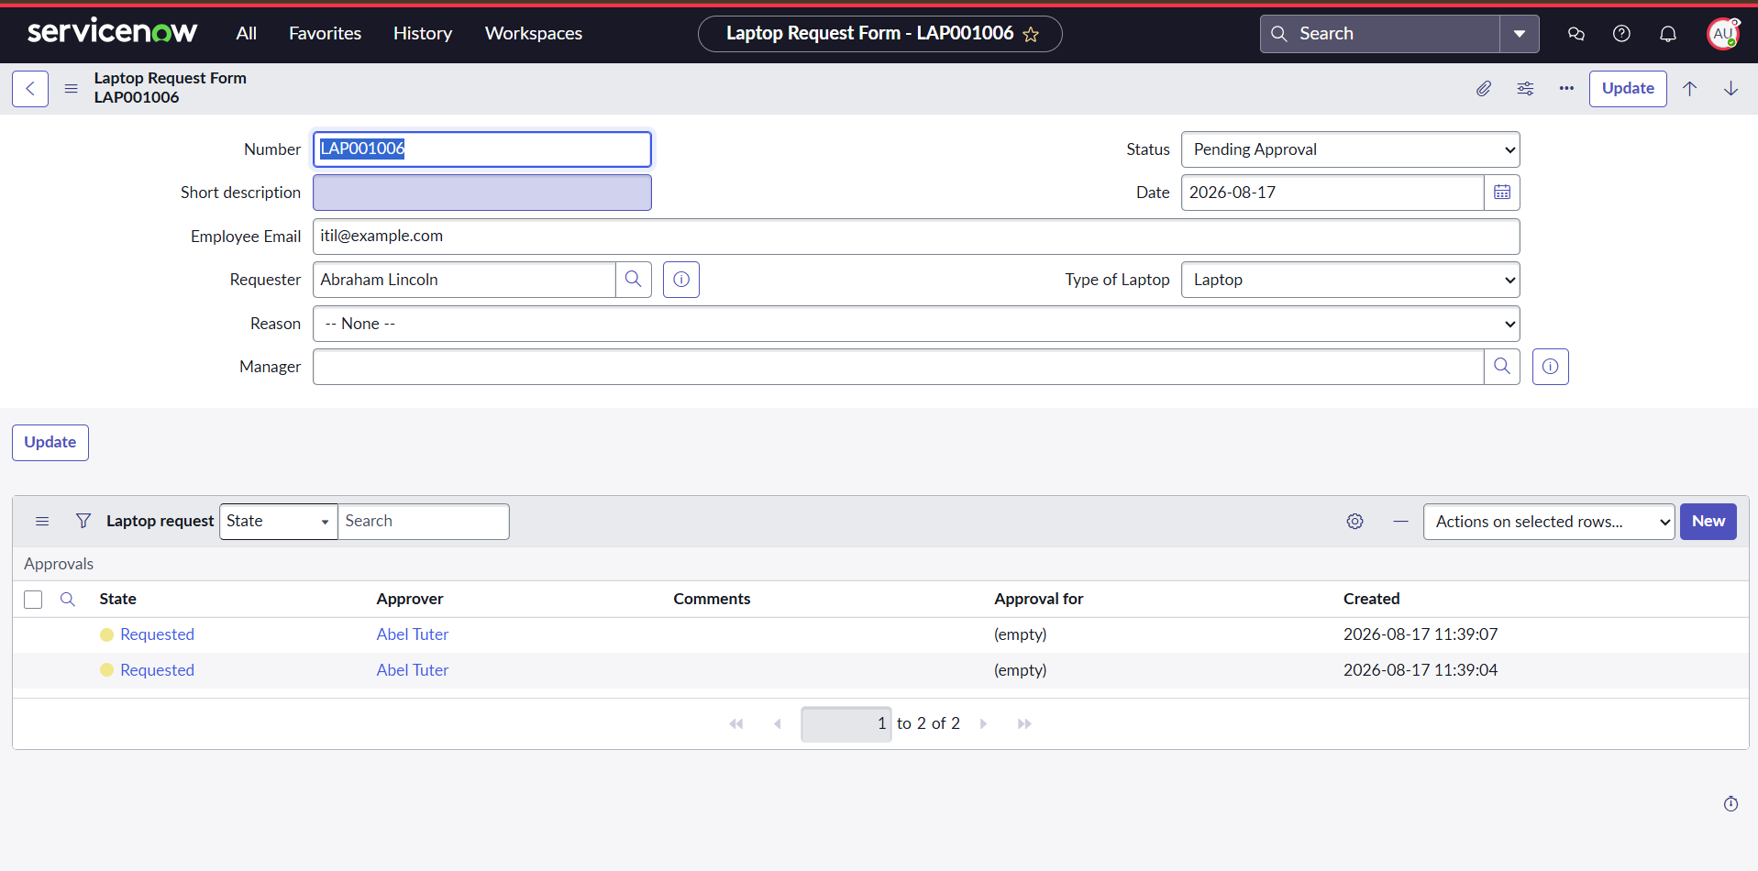
2. | Data Validation | Required request information is validated during submission. The configured Business Rule prevents duplicate laptop requests for the same user within the current calendar year.  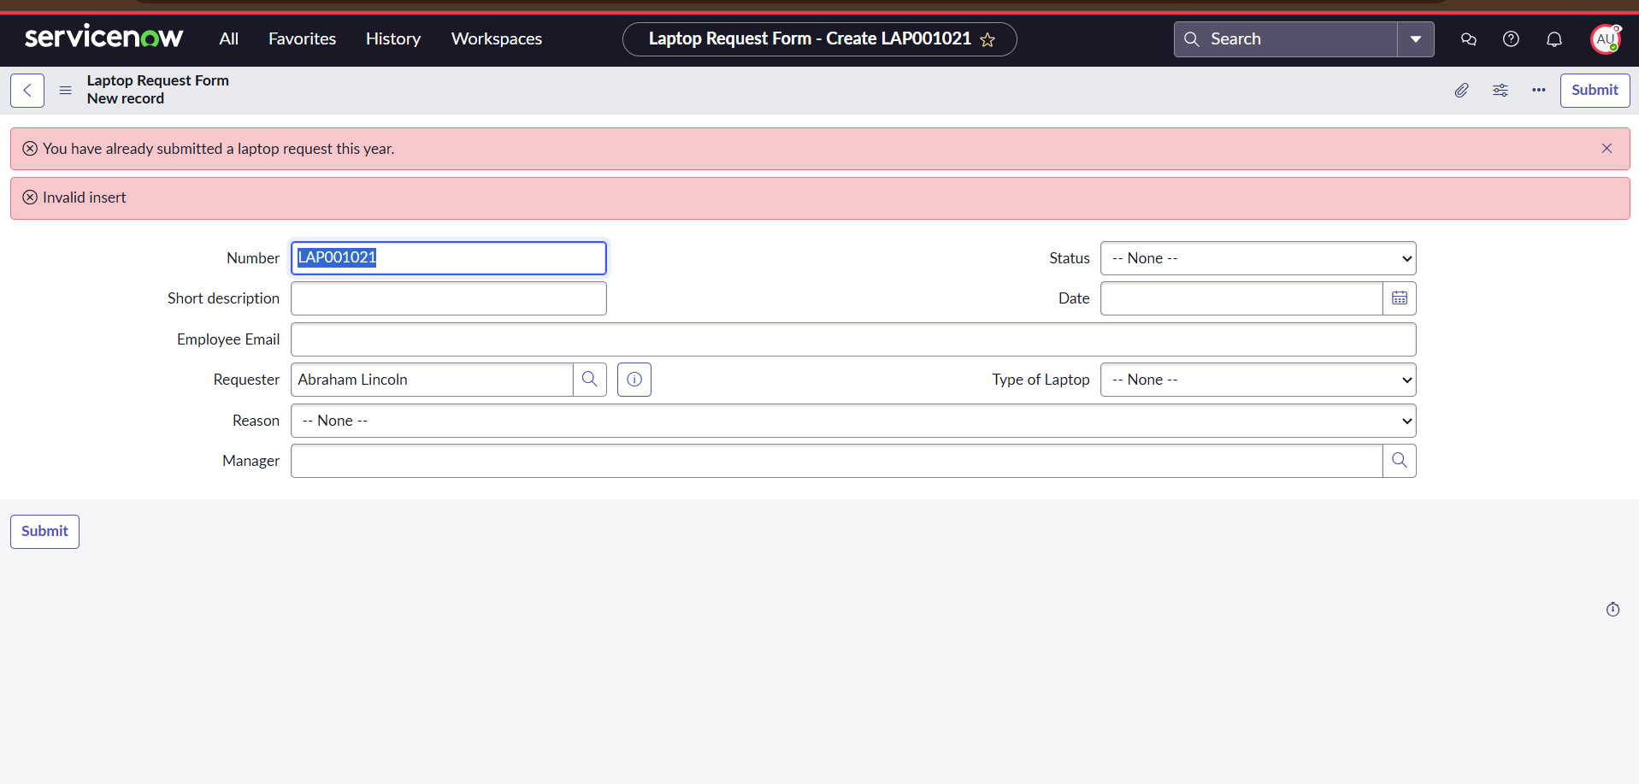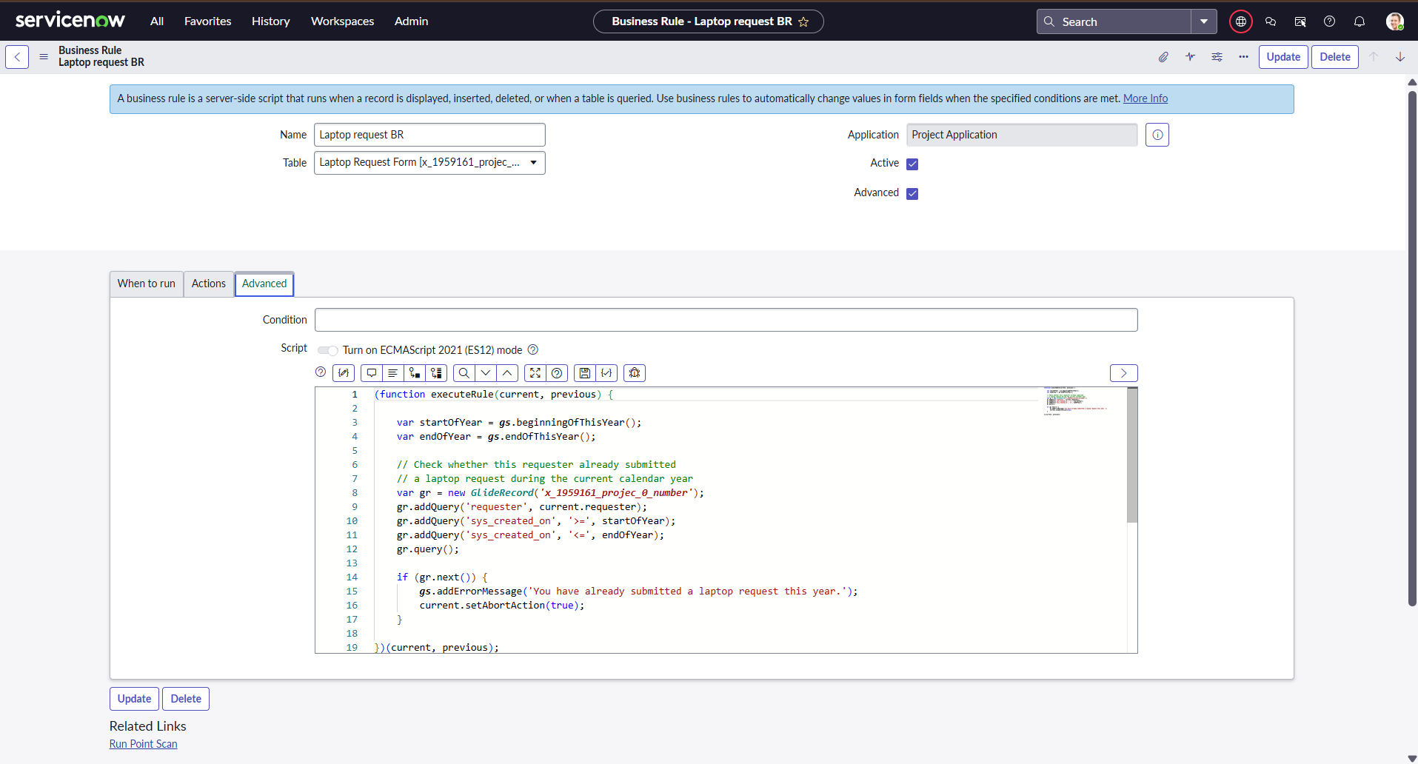
3. | Utilization of Filters | Laptop request records can be searched and filtered using available list conditions such as requester, request status, and approval-related information.  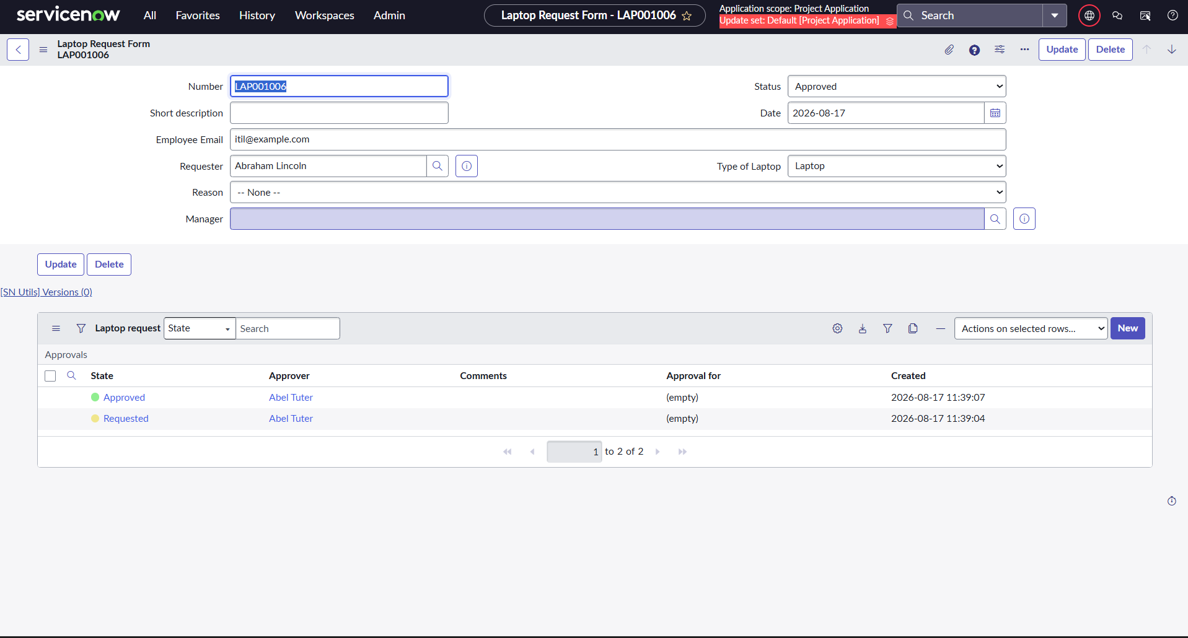
4. | Calculated / Derived Information | The current Laptop Request Management System does not use separate calculated or derived information fields for performance testing.  Value: Not Applicable.
5. | Dashboard Design | No separate dashboard visualization was implemented in the current version of the Laptop Request Management System.  No. of Visualizations / Graphs: Not Applicable.
6. | Report / Story Design | No separate report or story visualization was implemented in the current version of the Laptop Request Management System.  No. of Visualizations / Reports: Not Applicable.

Conclusion:
The Laptop Request Management System was reviewed for request data, data validation, record filtering, workflow-related information, and the availability of reporting and dashboard functionality. The implemented ServiceNow workflow supports laptop request submission, validation, manager approval, role-based access, notifications, and request tracking.
Note:
Only actual ServiceNow features and screenshots should be inserted. Do not add screenshots for features that were not implemented. Use “Not Applicable” where a feature is not part of the project.

